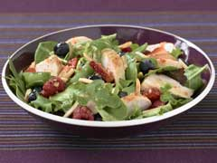
Chicken Berry Salad

Recipe Rating:

Prep Time: 20 min
Total Time: 20 min
Makes: 6 servings, about 2 cups each

8 cups torn mixed salad greens
1 lb. boneless skinless chicken breasts,
cooked, cut into strips
2 cups fresh berries (raspberries, blueberries,
sliced strawberries)
1 pkg. (8 oz.) frozen sugar snap peas, thawed
1/4 cup chopped toasted PLANTERS Pecans or Slivered Almonds
1 cup prepared GOOD SEASONS Italian Salad Dressing & Recipe Mix (prepared with less oil version as directed on pkg.)

TOSS salad greens with all remaining ingredients except the dressing in large bowl.
ADD dressing; mix lightly.

KRAFT KITCHENS TIPS
Great Substitute
Prepare as directed, using 1 bag (10 oz.) torn salad greens.

NUTRITION INFORMATION
Nutrition Bonus:
Toss up a good source of vitamin C with the strawberries in this colorful salad.
Diet Exchange:
2 Fat,1/2 Fruit,3 Meat (VL),1 Vegetable

Nutrition (per serving)
Calories 260 Total fat 15g Saturated fat 2g Cholesterol 50mg Sodium 480mg Carbohydrate 13g Dietary fiber 4g Sugars 4g Protein 20g Vitamin A 15%DV Vitamin C 50%DV Calcium 6%DV Iron 10%DV

